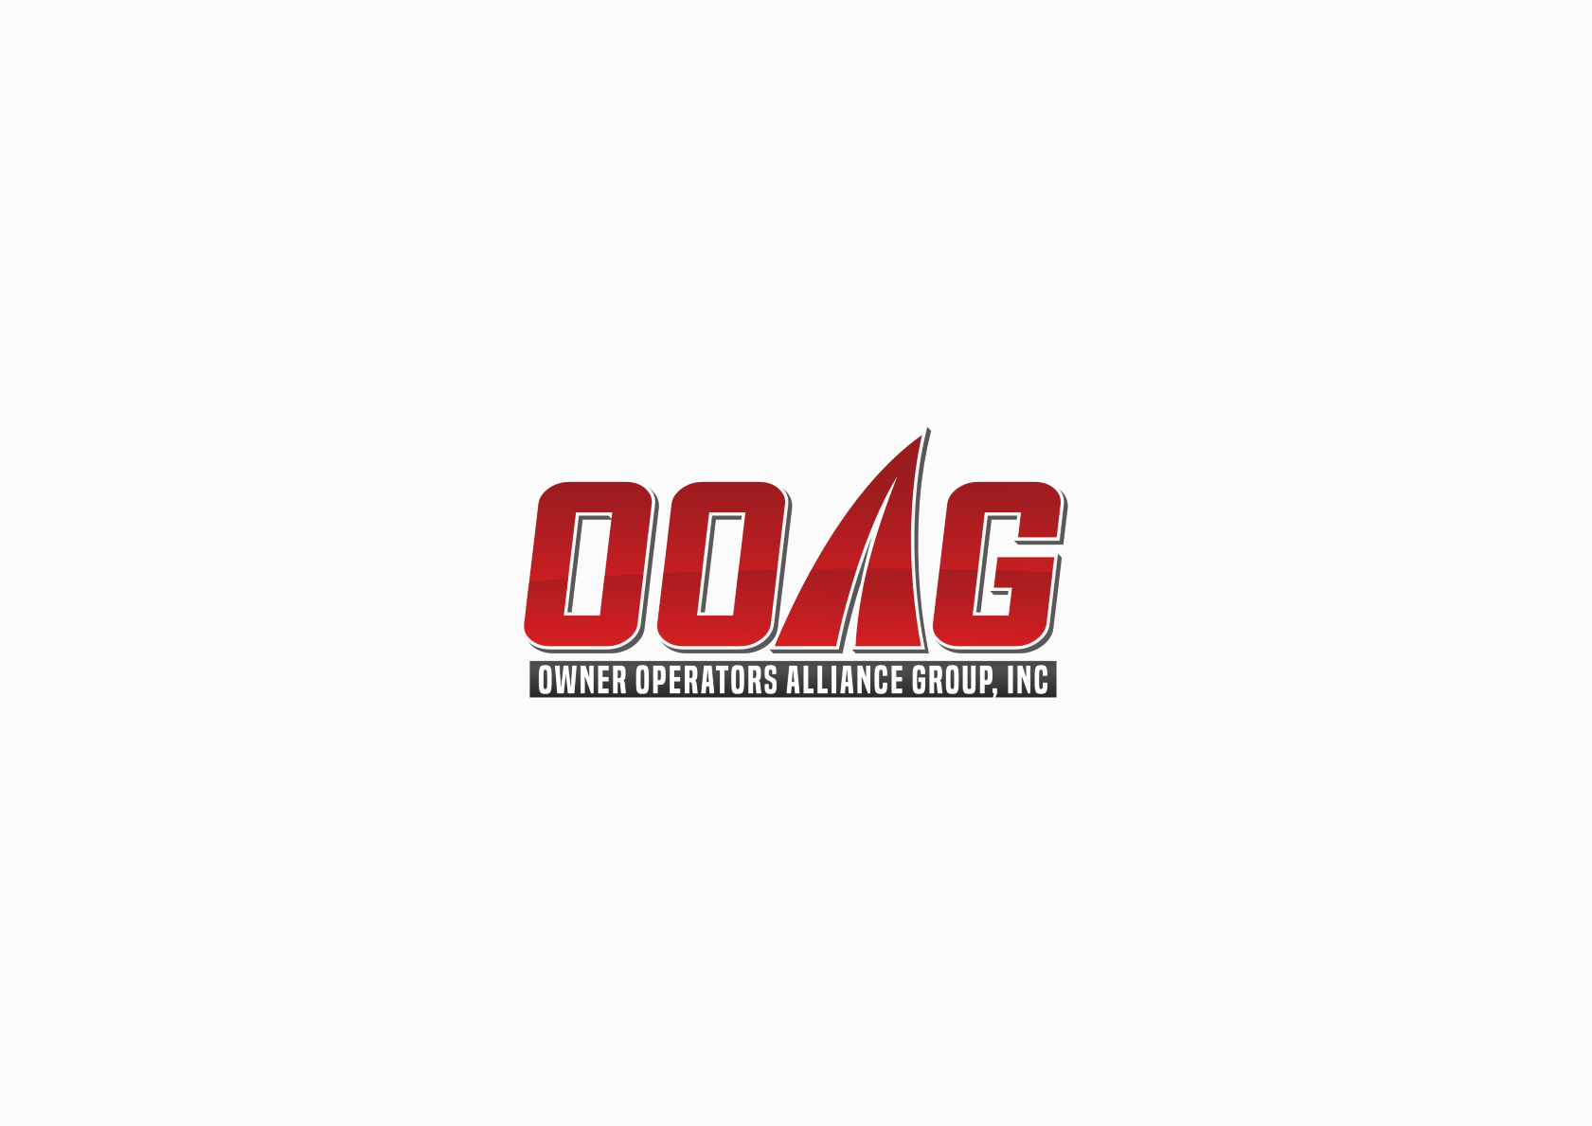 | Independent Contractor  Non-Trucking & Physical Damage Application  Phone: (866) 888-9009 Fax: (630) 230-2055

Owner Name: |  |  |  |  |  |  |  |  |  |  | Requested  Eff. Date:
Entity Name: |  |  |  |  |  |  |  |  |  |  | FEIN/SSN
Mailing Address:
City: |  |  |  |  |  |  | State: |  |  |  |  |  | Zip:
Phone #: |  |  |  |  | Fax #:
Entity Type |  |  | Corporation | LLC |  |  |  | Sole Proprietor |  |  |  |  |  |  | Partnership
CONTRACTED WITH:
***Please check requested coverage:
Non-Trucking Liability |  |  |  |  |  | Physical Damage
NTL Limit: |  | $ 1,000,000 CSL BI PD, $0 DED. |  |  |  | Comp & Collision, Subject to Stated Limit
UM Limit: |  | STATUTORY |  |  |  | Comp/Coll Deductibles: |  |  |  |  |  |  |  | $1,000  $2,500 Fire  $5,000 Theft Related
***If Physical Damage Coverage is requested, it is the responsibility of the OWNER to assign the correct Insured Value and provide correct lien holder information.
Type of Equipment:
Extra Heavy Truck (Over 46,000 lbs. GVW) |  |  |  |  |  | Medium Truck (under 26,000 lbs. GVW)
Heavy Truck (26,000 lbs. GVW) |  |  |  |  |  | Cargo Van or Light Truck
Average Daily Radius of Operation:
Local (0-100 miles) | Intermediate (100-300 miles) | Long Haul (> 500 miles)

Vehicle Description
Year | Make | VIN | Insured Value
State | GVW | Commodities Hauled:

Name of Lien Holder Mailing Address

**Driver Information (List ALL Drivers, Report All Driver Changes Immediately)
 | Name |  | DOB | ST | License No. | SS#
1.
2.
Print Name:

